**Experiment No. 1a**

**Aim:** Write a program to test active sensor using smart boards.

**Apparatus:** Temperature Sensor, Arduino Uno, Connecting Wire.

**Theory:**

Temperature Sensor

A temperature sensor is a device, usually an RTD (resistance temperature detector) or a thermocouple, that collects the data about temperature from a particular source and converts the data into understandable form for a device or an observer. Temperature sensors are used in many applications like HVand AC system environmental controls, food processing units, medical devices, chemical handling and automotive under the hood monitoring and controlling systems, etc.

The most common type of temperature sensor is a thermometer, which is used to measure temperature of solids, liquids and gases. It is also a common type of temperature sensor mostly used for non-scientific purposes because it is not so accurate.

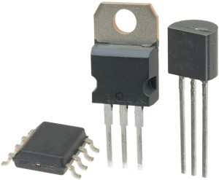

Arduino

[Arduino](http://arduino.cc/) is an open-source platform used for building electronics projects. Arduino consists of both a physical programmable circuit board (often referred to as a [microcontroller](http://en.wikipedia.org/wiki/Microcontroller)) and a piece of [software](http://arduino.cc/en/Main/Software), or IDE (Integrated Development Environment) that runs on your computer, used to write and upload computer code to the physical board.

The Arduino platform has become quite popular with people just starting out with electronics, and for good reason. Unlike most previous programmable circuit boards, the Arduino does not need a separate piece of hardware (called a programmer) in order to load new code onto the board -- you can simply use a USB cable. Additionally, the Arduino IDE uses a simplified version of C++, making it easier to learn to program. Finally, Arduino provides a standard form factor that breaks out the functions of the micro-controller into a more accessible package.

[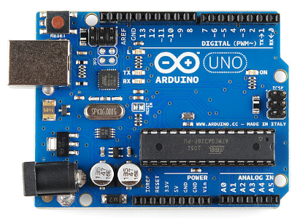](https://cdn.sparkfun.com/assets/9/1/e/4/8/515b4656ce395f8a38000000.png)

**Circuit Diagram:**

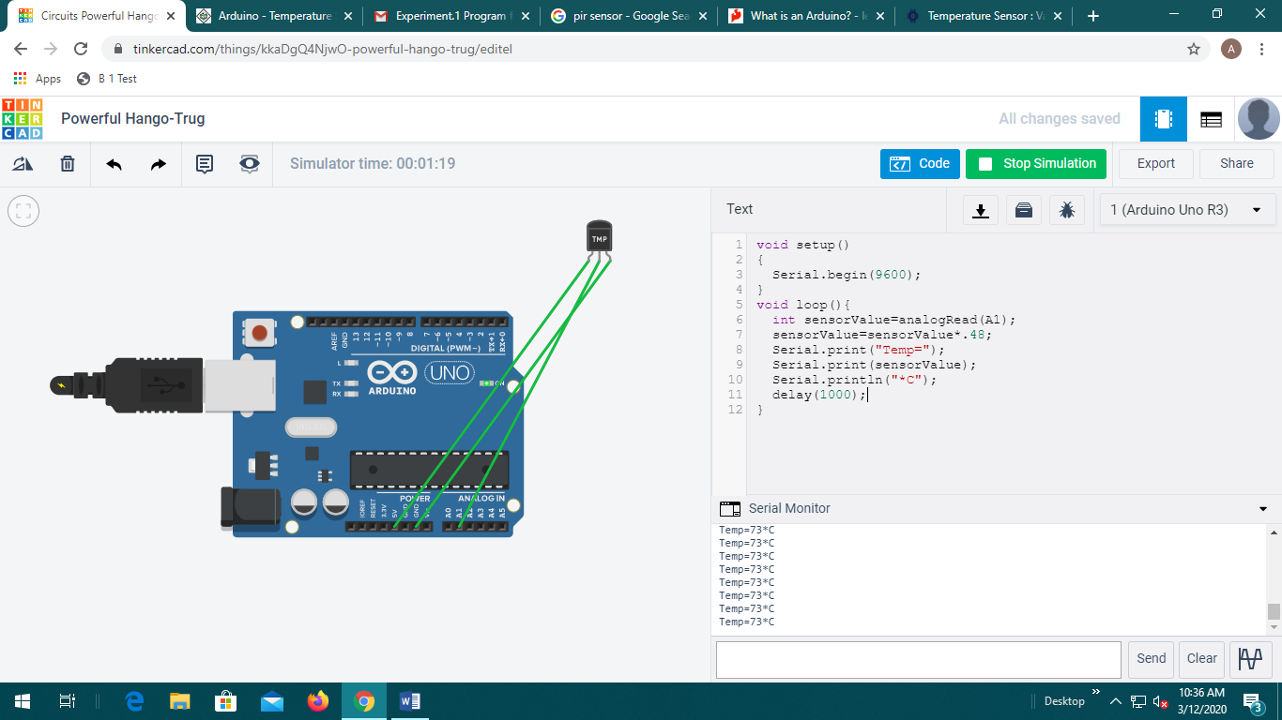

**Code**:

void setup()

{

Serial.begin(9600);

}

void loop(){

int sensorValue=analogRead(A1);

sensorValue=sensorValue*.48;

Serial.print("Temp=");

Serial.print(sensorValue);

Serial.println("*C");

delay(1000);

}

**Features:**

Calibrated directly in ˚ Celsius (Centigrade)

Rated for full l −55˚ to +150˚C range

Suitable for remote applications

Low cost due to wafer-level trimming

Operates from 4 to 30 volts

Low self-heating,

±1/4˚C of typical nonlinearity

**Result:**

